SQL Query Explanation

- List all products:
SQL:

SELECT * FROM products;

Answer: 110 rows, all columns ( ProductCode, ProductName, Productline, etc)
This query retrieves every column and row from the products table. There is no filter or join.

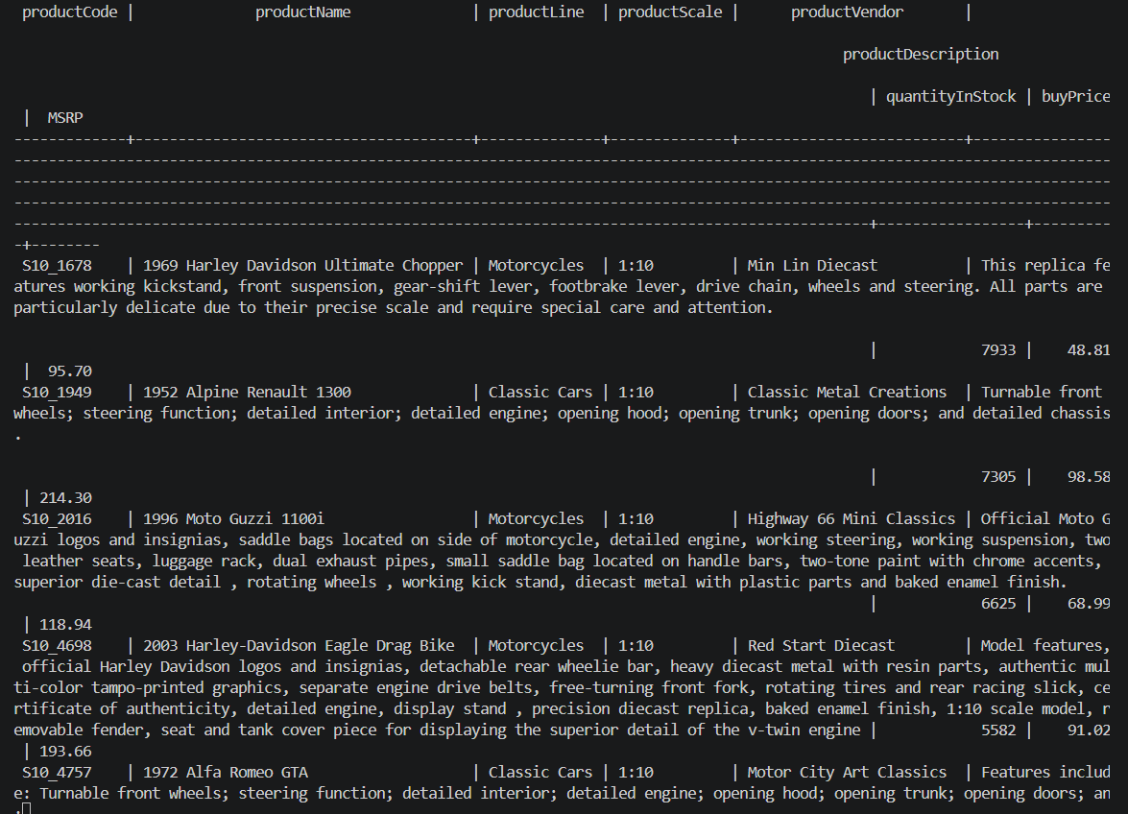

- Get all customers:
SQL:
SELECT * FROM customers;

Answer : 122 rows, all customer details.
Selects all columns from the customers table, returning every customer record.

- Show all orders:
SQL:
SELECT *FROM orders;

Answer: 326 rows, all order fields.
Fetches all orders without any condition.

- List all employees:
SELECT *FROM employees;

Answer: 23 rows, all employee information.
Returns every employee row from the employees table.

- Get all offices
SQL:
SELECT *FROM offices;

Answer: 7 rows, all office details.
Simple select from the offices table.

- Show all product lines
SQL:
SELECT *FROM productlines;

Answer: 7 rows, each product line category.
Retrieves all records from productlines.

7.List all payments
SQL:
SELECT *FROM payments;

Answer: 273 rows, payment transactions.
Full table scan of payments.

8. Get product names and prices
SQL:
SELECT “productName” , “buyPrice” FROM products;

Answer: 110 rows, two columns per product.
Only product name and purchase price are selected, not all columns.

9. Get customer names and cities
SQL:
SELECT “customerName”, “city” FROM customers;

Answer: 122 rows, customer name + city.
Projects only the required columns.

10. List employee first and last names
SQL:
SELECT “firstName”, “LastName” FROM employees;

Answer: 23 rows of names.
Selects on;y first and last name columns.

11. Get all order dates
SQL:
SELECT “orderDate” FROM orders;

Answer: 326 rows (dates may be repeated)
Returns only the order date column from orders.
12. Show product vendor list
SQL:
SELECT DISTINCT “productVendor” FROM products ORDER BY “productVendor”;

Answer: 13 distinct vendors.
DISTINCT removes duplicate vendor names, and ORDER BY sorts alphabetically.

13. Get all product codes
SQL:
SELECT “productCode” FROM products;

Answer: 110 rows ,each product’s unique code.
Simple projection of the primary key column.

14. List all countries from offices
SQL:
SELECT DISTINCT “country” FROM offices;

Answer: 5 countries ( ie USA, France, Japan, Australia, UK).
Unique countries where offices are located.

15. Show all order statuses
SQL:
SELECT DISTINCT “status” from orders;

Answer: 6 statuses ( Shipped, Cancelled, Resolved, On Hold, Disputed, In Process).
Distinct values from the status column.

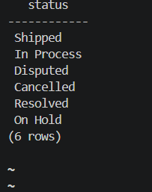

16. Get all payments amounts
SQL:
SELECT “amount” FROM payments;

Answer: 273 rows, one amount per row.
All payment amounts ( with duplicates).

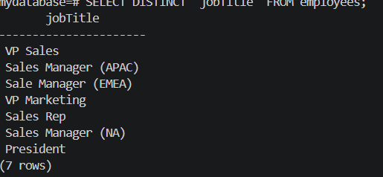
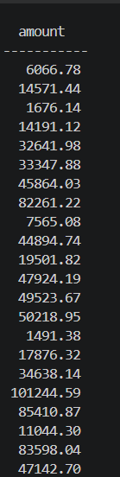

17. List all job titles
SQL:
SELECT DISTINCT “JobTitle” FROM employees;

Answer: 7 unique job titles.
Distinct employee Job titles,
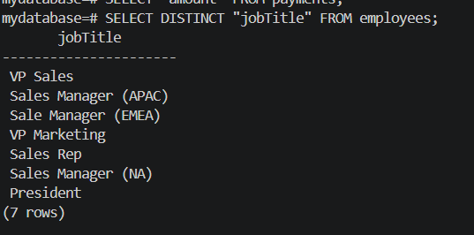

18. Get customer phone numbers
SQL:
SELECT “customerName”, “phone” FROM customers;

Answer: 122 rows with name and phone. Two columns selected.
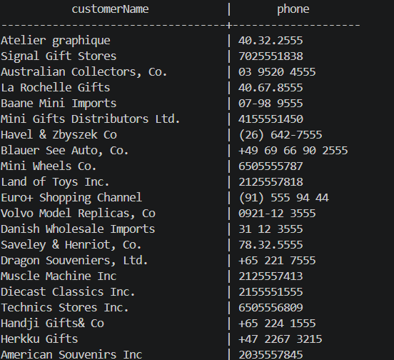

19. Show product MSRP values
SQL:
SELECT “productName”, “MSRP” FROM products;

Answer: 110 rows, product name and suggested retail price.
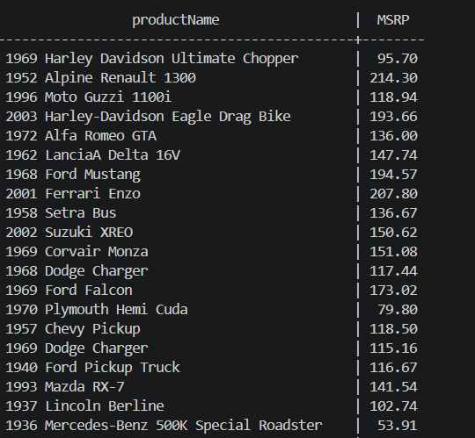

20. List order numbers
SQL:
SELECT “orderNumber” FROM orders;

Answer: only 326 order number columns.
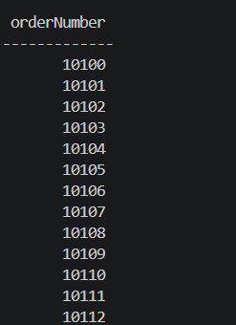
21. Get orders with customer names
SQL:
SELECT o.”orderNumber”, c.”customerName”
FROM orders o
JOIN customers c ON o.”customerNumber” = c.”customerNumber”;

Answer: 326 rows, each order paired with the customer name.
JOIN links orders and customers via customerNumber; shows order number and who placed it.

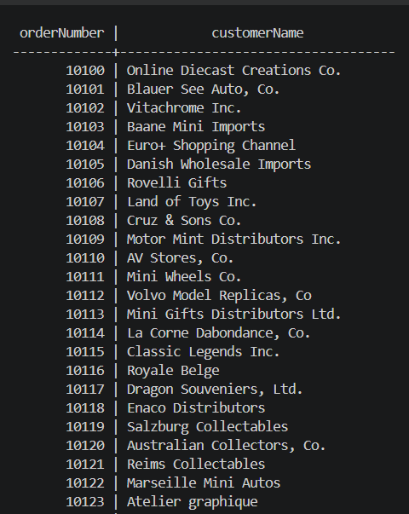

22. Get employees with office city
SQL:

SELECT e.”firstName”, e.”lastName” , o.”city”
FROM employees e
JOIN offices o ON e.”officeCode” = o.”officeCode”;

Answer: 23 rows, employee names plus their office city. Join employees to offices using officeCode.

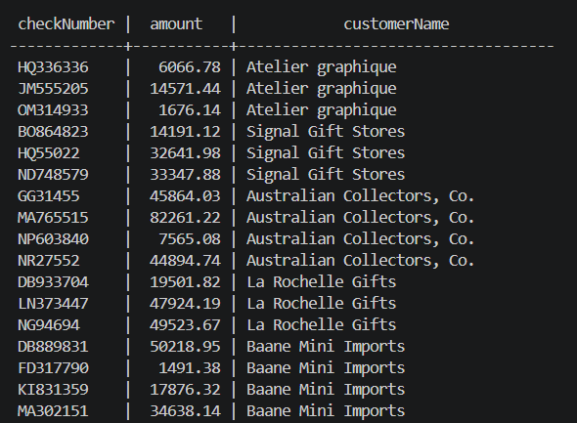

23. Get payments with customer names
SQL:
SELECT p.”checkNumber” , p.”amount”, c.”customerName”
FROM payments p
JOIN customers c ON p.”customerNumber” = c.”customerNumber”;

Answer: 273 rows, each payment with the customer’s name. The payment table joined the customers to show who made the payment.
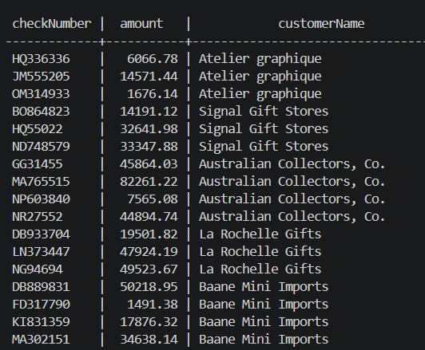

24. Get order details with product names
SQL:
SELECT od.”orderNumber”, p.”productName”, od.”quantityOrdered”, od.”priceEach”
FROM orderdetails od
JOIN products p ON od.”productCode” = p.”productCode”;

Answer: 2996 rows ( each order line item with product name). Links orderdetails to products via product code to show product name for each item ordered.

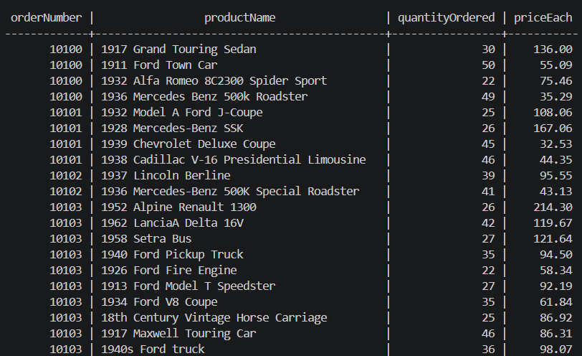

25. Get products with product line description
SQL:
SELECT p.”productName”, pl.”textDescription”
FROM products p
JOIN productlines pl ON p.”productLine” = pl.”productLine”;

Answer: 110 rows, each product name with its product line’s description. Join between products and productionlines to include the text description.
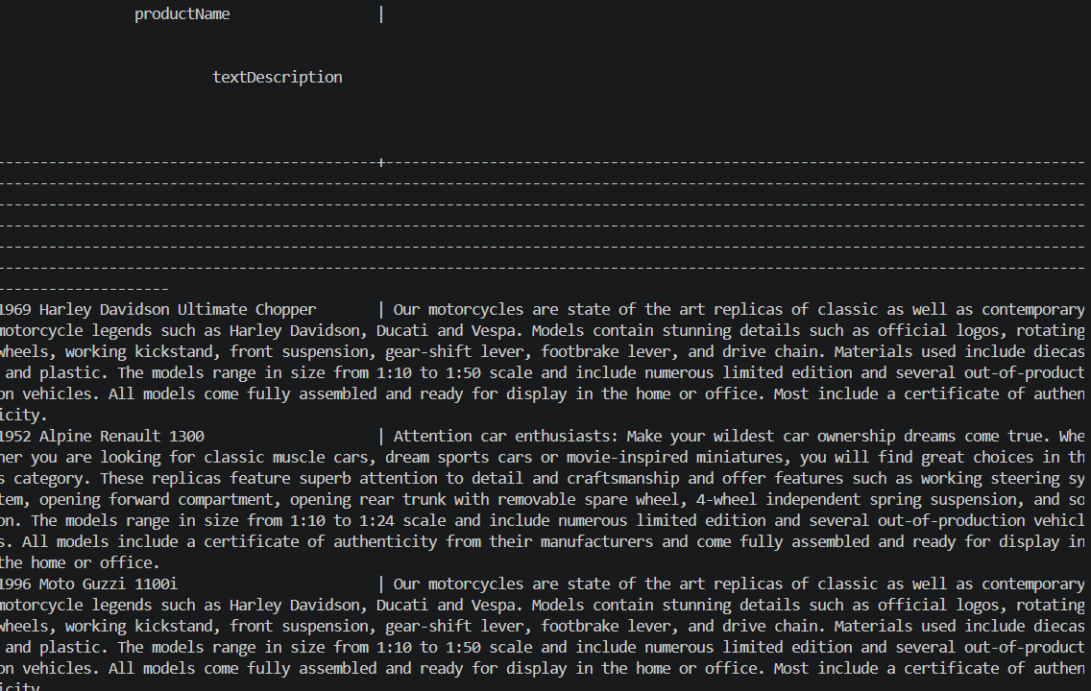

26. Get customers with sales rep names
SQL:
SELECT c.”customerName”, e.”firstName”, e.”lastName”
FROM customer c
LEFT JOIN employees e ON c.”salesREpEmployeeNumber” = e.”employeeNumber”;

Answer: 122 rows; customers without a rep show NULL for the rep name.
LEFT JOIN ensures all customers appear even if they have no assigned sales representative.
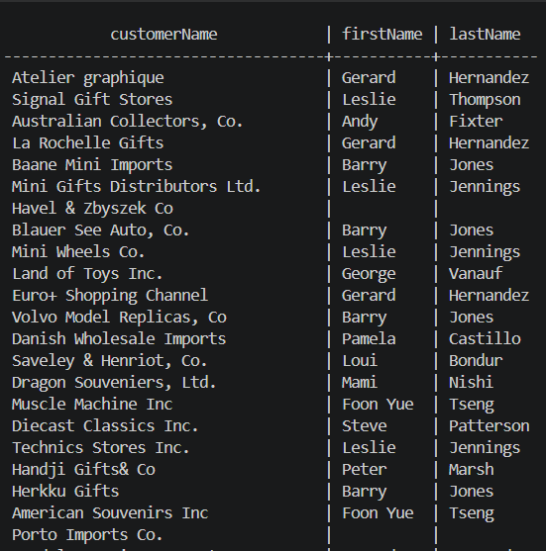

27. Get orders with customer city
SQL:

SELECT o.”orderNumber” , c.”city”
FROM orders o
JOIN customers c ON o.”customerNumber” = c.”customerNumber”;

Answer: 326 rows shadowing order number and the customer’s city. Join orders to customers, project order number and city/
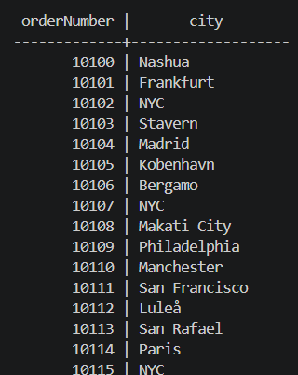

28. Get employees and their manager
SQL:
SELECT e.”firstName” AS employee_first, e.”lastName” AS employee_last,
m.”firstName” AS manager_first, m.”lastName” AS manager_last
FROM employees e
LEFT JOIN employees m on e.”reportsTo” = m.”employeeNumber”;
Answer: 23 rows; the president has a NULL manager. Self-join on reportsTo to match each employee with their manager.

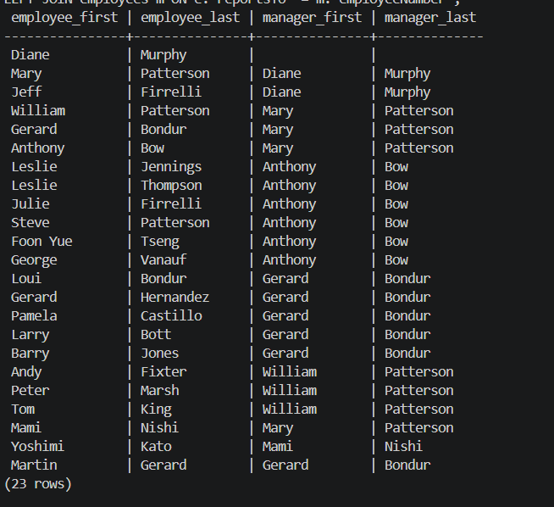

29. Get orderdetails with product vendor
SQL:
SELECT od.”orderNumber”, p.”productName”, p.”productVendor”
FROM orderdetails od
JOIN products p ON od.”productCode” = p.”productCode”;
Answer: 2996 row, each order line item include the product vendor.
Join orderdetails to products to retrieve vendor information.
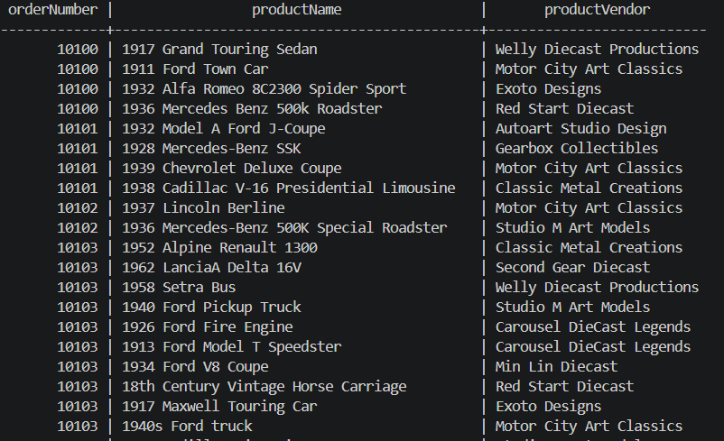

30. Get payments with customer country
SQL:
SELECT p.”checkNumber” , p.”amount” , c.”country”
FROM payments p
JOIN customers c ON p.”customerNumber” = c.”customerNumber”;

Answer: 273 rows, each payment shows the customer’s country. Join payments with customers to get country.
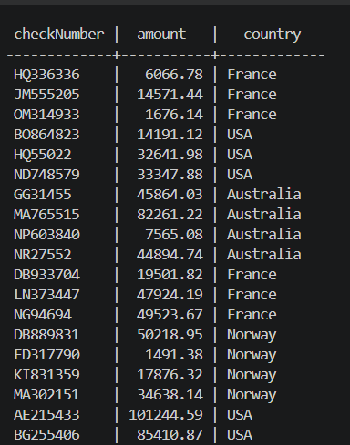

31. Count customers per country
SQL:
SELECT “country”, COUNT(*) AS customer_count
FROM customers
GROUP BY “country”
ORDER BY customer_count DESC;

Answer: Approximately 21 rows, e.g, USA: 36, France: 12 etc. GROUP BY country and COUNT(*) gives number of customers per country; ordered highest first.
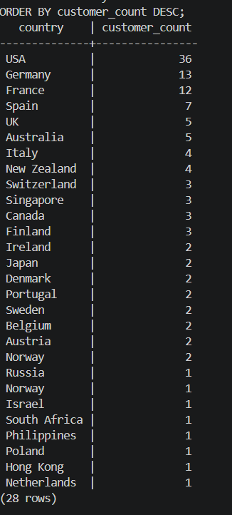

32. Total Payments per customer
SQL:
SELECT c."customerName", SUM(p."amount") AS total_paid
FROM customers c
JOIN payments p ON c."customerNumber" = p."customerNumber"
GROUP BY c."customerNumber", c."customerName"
ORDER BY total_paid DESC;

Answers: 98 rows (only customers who paid) with total amount paid. Sums payment amount per customer using sum and group by.

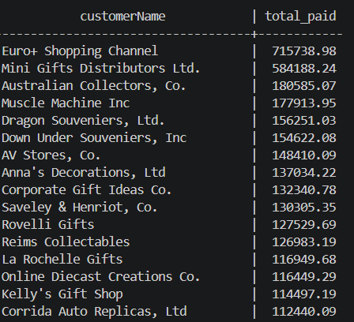

33. Number of orders per status
SQL:
SELECT "status", COUNT(*) AS order_count
FROM orders
GROUP BY "status"
ORDER BY order_count DESC;

Answer: 6 rows, e.g. Shipped: 303, Cancelled: 6, etc. Groups orders by status and counts them.

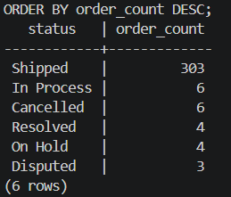

34. Products per product line
SELECT pl."productLine", COUNT(p."productCode") AS product_count
FROM productlines pl
LEFT JOIN products p ON pl."productLine" = p."productLine"
GROUP BY pl."productLine"
ORDER BY product_count DESC;

Answer: 7 rows; each product line shows how many products belong to it ( some may be zero). LEFT JOIN ensures all product lines appear; COUNT of product codes.

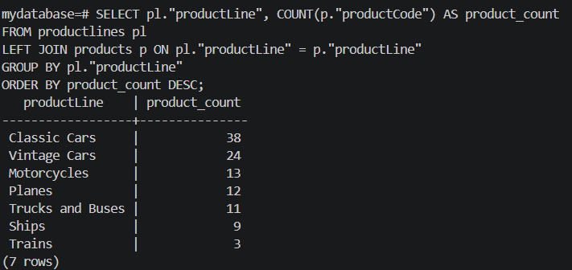

35. Employees per office
SQL:
SELECT o."city", COUNT(e."employeeNumber") AS employee_count
FROM offices o
LEFT JOIN employees e ON o."officeCode" = e."officeCode"
GROUP BY o."officeCode", o."city"
ORDER BY employee_count DESC;

Answer: 7 rows, number of employees in each office city. Group offices with employees, count employee numbers.

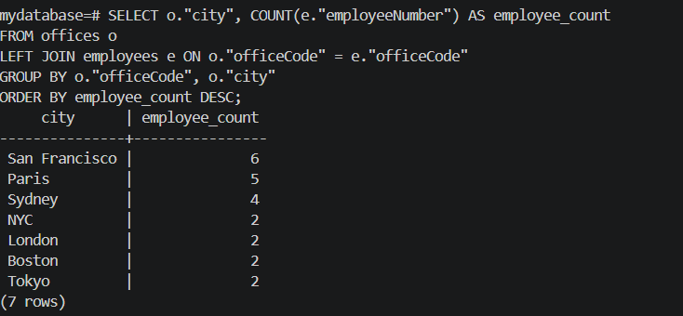

36. Total stock per product vendor
SQL:

SELECT "productVendor", SUM("quantityInStock") AS total_stock
FROM products
GROUP BY "productVendor"
ORDER BY total_stock DESC;

Answer: 13 rows, total inventory quality per vendor. Sums the quatityInStock for each vendor.

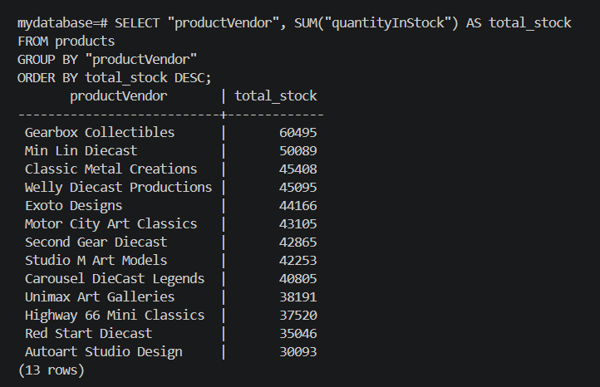

37. Average buy price per product line.
SQL:
SELECT p."productLine", AVG(p."buyPrice") AS avg_buy_price
FROM products p
GROUP BY p."productLine"
ORDER BY avg_buy_price DESC;

Answer: 7 rows, average purchase price for each product line. AVG ( buyPrice) grouped by product line.

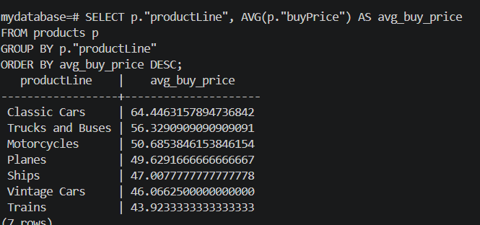

38. Orders per customer
SQL:
SELECT c."customerName", COUNT(o."orderNumber") AS order_count
FROM customers c
LEFT JOIN orders o ON c."customerNumber" = o."customerNumber"
GROUP BY c."customerNumber", c."customerName"
ORDER BY order_count DESC;

Answer: 122 rows; customers with no orders show 0. LEFT JOIN and COUNT of order numbers.

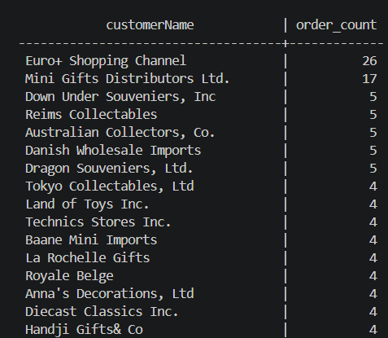

39. Max MSRP per product line
SQL:
SELECT "productLine", MAX("MSRP") AS max_msrp
FROM products
GROUP BY "productLine"
ORDER BY max_msrp DESC;

Answer: 7 rows, highest MSRP in each product line. MAX aggregate with GROUP BY.

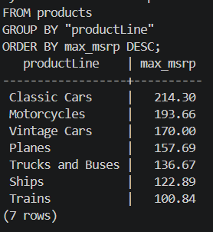

40. Min buy price per vendor
SQL:
SELECT "productVendor", MIN("buyPrice") AS min_buy_price
FROM products
GROUP BY "productVendor"
ORDER BY min_buy_price;

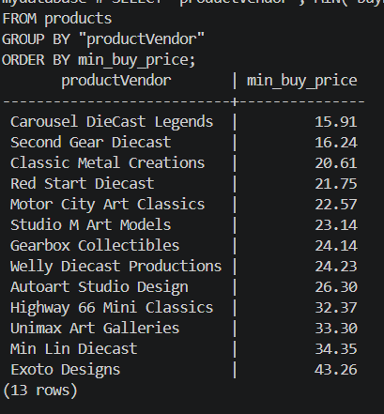
Answer: 13 rows, cheapest purchase price offered by each vendor. MIN ( buyPrice ) per vendor.

41. Total number of customers
SQL:
SELECT COUNT(*) AS total_customers FROM customers;
Answer: 122 row count of customers table

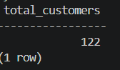

42. Total number of products
SQL:
SELECT COUNT(*) AS total_products FROM products;
Answer: 110 row count of products table.
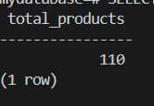

43. Total revenue from payments
SQL:
SELECT SUM(amount) AS total_revenue FROM payments;
Answer: Approximately 8,895,000. Sums all payment amounts.
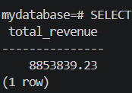

44. Average product price
SQL:
SELECT AVG("buyPrice") AS avg_buy_price FROM products;

Answer: approx 54.39.

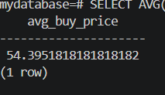

45. Max Payment Amount
SQL:
SELECT MAX(amount) AS max_payment FROM payments;

Answer: 120,166.58. Largest single payment value.
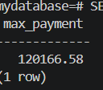

46. Min payment amount
SQL:
SELECT MIN(amount) AS min_payment FROM payments;

Answer: 615.45. Smallest payment value.
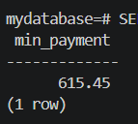

47. Count total orders
SQL:
SELECT COUNT(*) AS total_orders FROM orders;

Answer: 326. Number of order records
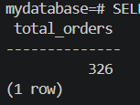

48. Total quantity in stock
SQL:
SELECT SUM("quantityInStock") AS total_stock FROM products;

Answer: approximately 2,800,000 ( exact depends on data). Sum of quantityInStock across all products.

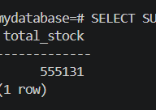

49. Average MSRP
SQL:
SELECT AVG("MSRP") AS avg_msrp FROM products;

Answer: 97.42. Average manufacturer’s suggested retail price.

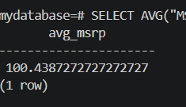

50. Number of employees
SQL:
SELECT COUNT(*) AS total_employees FROM employees;

Answer: 23. Row count of employees table.

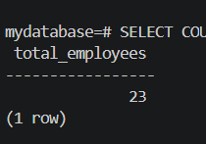

Why evaluation is hard for Text-to-SQL
SQL generation is a false proxy for correctness. Two queries can look completely different syntactically but return identical results — and one "correct-looking" query can silently return the wrong rows due to a wrong JOIN or an off-by-one filter. So you need to evaluate multiple dimensions.

Layer 1 : SQL correctness
The most studied layer. Three approaches, in increasing usefulness:
Exact Match (EM) compares the generated SQL token-by-token against a reference. It's simple to compute but overly strict; there are often many valid SQL phrasings for the same question.
Execution Accuracy (EX) is more meaningful: run both the generated SQL and the gold SQL, then compare the result sets. If they match, the query is functionally correct even if differently written. This is the standard metric on benchmarks like Spider and BIRD.
Component-level matching breaks the query into clauses (SELECT, WHERE, JOIN, GROUP BY) and scores each separately. This is invaluable for diagnosing where the model is failing. Is it selecting the wrong columns, or is the filtering wrong?
Use BIRD over Spider for realistic evaluation; it includes messier schemas, ambiguous questions, and complex multi-table queries that better reflect production conditions.

Layer 2 : Execution quality
A query can be "correct" in theory but still fail in practice:
- Error rate: how often does the generated SQL throw a syntax or runtime error?
- Valid SQL rate: does it parse correctly against your target dialect (PostgreSQL, MySQL, SQLite)?
- Latency: how long does the full pipeline take — NL input to final answer? This matters for user experience.
- Safety: critically important in production — does the agent ever generate DROP, DELETE, or UPDATE statements when only reads are expected? This deserves its own automated test suite.

Layer 3 : Answer quality
Even if the SQL is technically correct, the answer returned to the user might be incomplete, misleading, or poorly formatted.
Result set precision/recall compares the rows returned to the gold answer: precision = what fraction of returned rows are correct, recall = what fraction of correct rows were returned.
Human evaluation remains the gold standard for nuanced quality signals — judges can assess whether the answer actually addressed the user's intent, not just whether rows match.
LLM-as-judge is a scalable alternative to human eval. A separate LLM (or the same one with a different prompt) evaluates whether the final answer is factually consistent with the database and addresses the question. This is especially useful for free-form follow-up answers the agent might generate around the raw query result.

Layer 4 :Robustness
This is where most systems break down in production:
Test type | What it checks
Paraphrase stability | Same question, different wording → same answer?
Schema drift | Renamed columns, new tables added → does it adapt?
Ambiguity handling | Vague questions → does it ask for clarification or make wrong assumptions?
Out-of-scope detection | Questions the DB can't answer → does it say so, or hallucinate rows?
Cross-dialect | Does it work on PostgreSQL, BigQuery, SQLite without retraining?

Putting it together — a practical eval pipeline
A good eval setup combines all four layers:
- Automated regression suite — run EX accuracy + error rate on a fixed benchmark after every model change
- Human eval sprints : periodic spot-checks of answer quality on real user queries
- Shadow mode testing :in production, silently run the agent alongside a known-good query engine and compare results
- Red-team for safety : adversarial prompts specifically targeting destructive SQL generation
The single most important metric to track is execution accuracy on your own schema not on Spider or WikiSQL, but on queries actually asked by your users. Generic benchmarks measure general capability; your own query log measures actual usefulness.

